**UNIVERSITY OF DAR ES SALAAM**



**COLLEGE OF INFORMATION, COMMUNICATION AND TECHNOLOGY**

**DEPARTMENT OF ELECTRONICS AND TELECOMMUNICATION ENGINEERING**

**PROJECT REPORT**

**ES324: SYSTEM DESIGN AND IMPLEMENTATION**

**REPORT TITLE: SMART ELECTRIC ENERGY METER SYSTEM**

**STUDENT NAME:** SAID, MUNIR ISSA

**REGISTRATION NUMBER:** 2018-04-01854

**DEGREE PROGRAM:** BSc. TELECOMMUNICATION ENGINEERING

**LECTURER:** Dr. ISACK BULUGU

**DATE OF SUBMISSION:** 21Th JUNE 2021

# DECLARATION

I, Said Munir Issa with registration number of 2018-04-01854 from the college of information and communication technology (CoICT) at the department of Electronics and Telecommunication Engineering (ETE), hereby declaring that I have prepared and have written this report due to both skills and knowledge I have gained from my lecturer Dr. Isack Bulugu and also by following all regulations and requirements of writing reports without copying from any other report work.

# ABSTRACT

This report is the summary of my project of the Smart Electric Energy Meter. Smart Energy Meter is an electronic device that measures the most accurate amount of electricity consumed by a residence, business or any electrically-powered device. A smart meter is a reliable source for most accurate information of consumed energy that reduces the chance of error in the existing billing system to minimal.

Smart Electric Energy Meter will ensure that user(residence) and business owner (e.g. TANESCO) get accurate data at an instant they request through their mobile (GSM in simulation).

This case study of the project is recommended to the Electric driven company and household whose daily activities require electricity for their survival, and hence they minimize time and const for the run of the mentioned electricity.

# ACKNOWLEDGEMENT

I would like to thank the Almighty God for the love, grace, blessings and gift that was granted to me and the all-colleague members together. I’m very much indebted to convey my sincere gratitude to all who assisted me in one way or other way. It is impossible to mention them all but I feel obliged to give particular appreciation to the following:

Foremost, I am so much grateful for the college of information and communication technology (CoICT) for a nice program preparation and serious management to meet the requirement for the students to have knowledge and experience that he or she will use after finishing his or her degree program.

Sincerely appreciation to my lecturer Dr. Isack Bulugu for both his efforts and effectiveness in supervision that helped me to have a fair project and also how I can use my knowledge in order to help my society.

# TABLE OF CONTENTS

DECLARATION i

ABSTRACT ii

ACKNOWLEDGEMENT iii

TABLE OF CONTENTS iv

LIST OF ABBREVIATIONS v

LIST OF FIGURES vi

CHAPTER 1: PROJECT DESCRIPTION 1

1.1. Project Background 1

1.2. Problem Statement 1

1.3. Rationale/Knowledge Gap 1

1.4. Objectives 1

1.4.1. Main Objective 1

1.4.2. Specific Objectives 1

CHAPTER 2: SYSTEM ANALYSIS AND DESIGN 3

2.1. Project Requirements 3

I. Control Unit 3

II. Alert Unit 3

2.2. Block diagram of the designed system 4

2.3. Schematic Circuit 4

2.4. Simulation Results 4

2.5. Recharge electric meter 5

2.6. Notification at 50% of unit used 5

2.7. Notification at 75% of unit used 5

2.8. Notification when all units is finished 6

2.9. Conclusion 6

REFERENCES 7

# LIST OF ABBREVIATIONS

COICT College of Information, Communication and Technology

LED Light Emitting Diode

# LIST OF FIGURES

Figure 1: Arduino Uno board 3

Figure 2: Light Emitting Diode 3

Figure 3: Block diagram of smart electric energy meter 4

Figure 4: Schematic Circuit 4

Figure 5: Simulation Results 4

Figure 6: Recharge electric meter 5

Figure 7: Notification when units is 50% used 5

Figure 8: Notification when units is 75% used 5

Figure 9: Notification when all units is finished 6

# CHAPTER 1: PROJECT DESCRIPTION

## Project Background

Electrical power has become indispensable to human survival and progress. Apart from efforts to meet growing demand, automation in energy is also necessary to enhance people’s living standard. In an electric power distribution system, the utility company and the customer meet at a point called the electric energy meter.

Traditionally, in Tanzania the electricity meter reading is accomplished by a human operator, which makes it difficult to meet the future residential expansion needs. Currently, a person has to manually enter token to electric energy meter using keypad, he should be physically present where meter is. The same applies when one wants to view remaining units and usage.

Smart electric energy came to solve the aforementioned issues. One buys electric units; the units automatically updates in the meter. Also, when viewing remaining units, sending SMS “RUD” to the meter will give an output of the remaining power through your phone.

## Problem Statement

The major problem is the manual insertion of token in electric energy meter and the way currently we read remaining units in electric energy meter. It is rather time consuming and can lead to negative consequence of the immediate electric cut unknowingly of the remaining units.

## Rationale/Knowledge Gap

The existing solution does solve the problem stated, but it is time consuming and it is inefficient in one way or the other. It is more manual than automatic.

## Objectives

This project objective is divided into two categories which are main and specific objectives:

### Main Objective

Designing and Implementation of the Smart Electric Energy Meter System.

### Specific Objectives

1. To automate insertion of token to electric energy meter.
2. To automate meter reading through mobile phone (GSM and virtual terminal in simulation).
3. Remote remaining unit’s notification in term of percentage of units.

# CHAPTER 2: SYSTEM ANALYSIS AND DESIGN

## Project Requirements

The system requires different components which categorized into three groups as follows;

### Control Unit

* 1. ARDUINO UNO

This is an open-source electronic platform. It is easy to use and has a large user community. The instructions set on the microcontroller on the Arduino board are written using the Arduino programming language. It is useful for fast prototyping as it does not rely much on the user background in programming and electronics.

Arduino microcontrollers operate with voltage between 3.3V to 12V.

There are several Arduino board families but the most used is ARDUINO UNO. It has 14 digital/output pins with 6 PWM pins, and 6 analog pins.

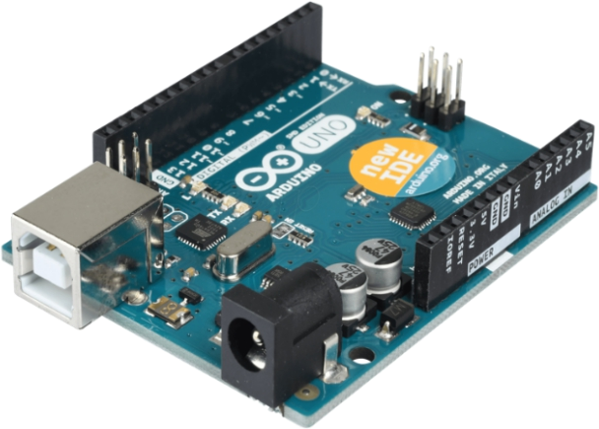

Figure 1: Arduino Uno board

### Alert Unit

* 1. Light Emitting Diode

It is the semiconductor device that emits light when an electric current is passed through it. In this project LED is turned ON when …

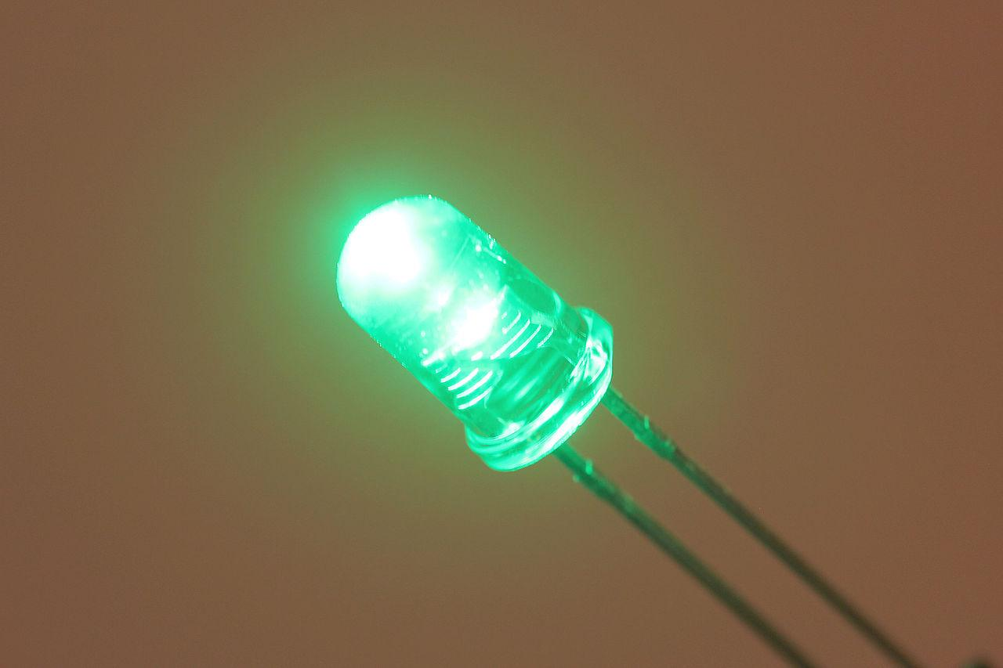

Figure 2: Light Emitting Diode

## Block diagram of the designed system

The following shows different blocks that I have used in simulation of Smart Energy Meter.

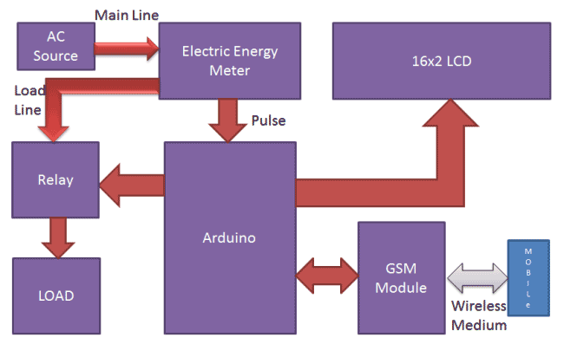

Figure 3: Block diagram of smart electric energy meter

## Schematic Circuit

The diagram below shows schematic circuit of the Smart Electric Energy Meter

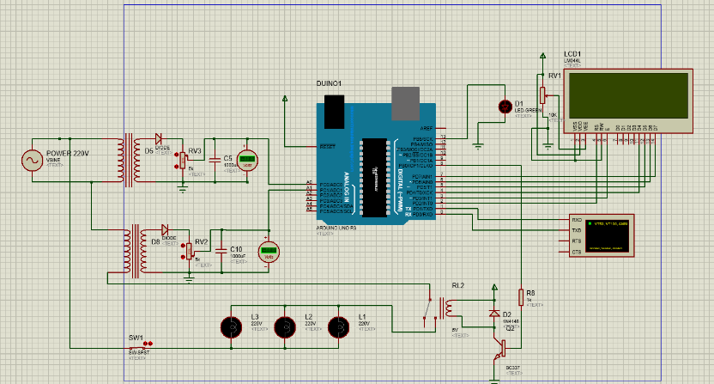

Figure 4: Schematic Circuit

## Simulation Results

When the simulation starts, virtual circuits starts as shown below;

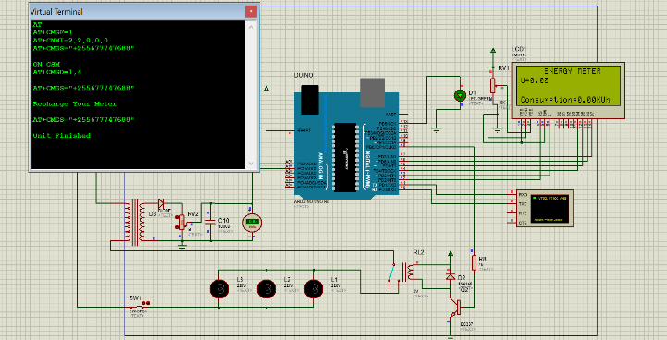

Figure 5: Simulation Results

## Recharge electric meter

To recharge meter, you are required to send “RU1”, number in SMS denote 100TZS.

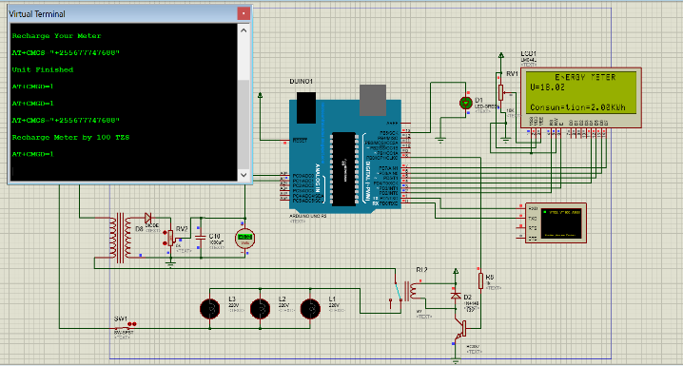

Figure 6: Recharge electric meter

## Notification at 50% of unit used

At 50% of units used, the electric energy meter sends and SMS to the user to notify on the energy remained.

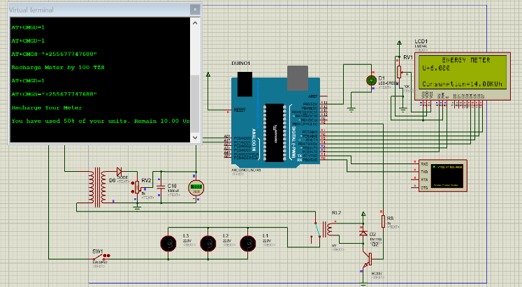

Figure 7: Notification when units is 50% used

## Notification at 75% of unit used

At 75% of units used, the electric energy meter sends and SMS to the user to notify on the energy remained.

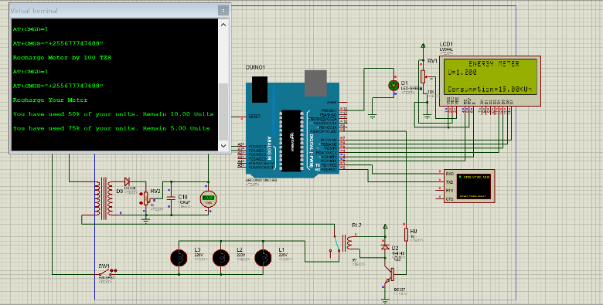

Figure 8: Notification when units is 75% used

## Notification when all units is finished

When units are finished, the electric energy meter sends and SMS to the user to notify that all the units is finished.

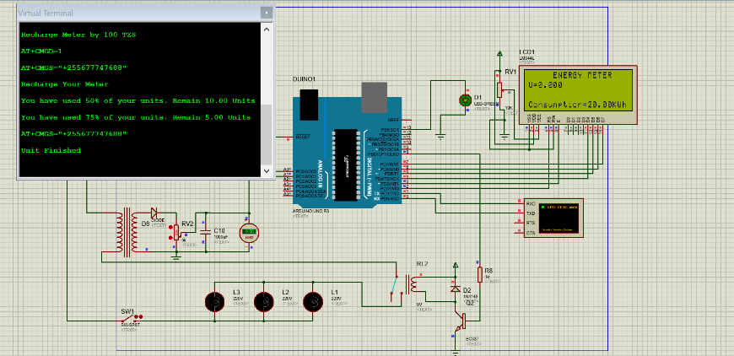

Figure 9: Notification when all units is finished

## Conclusion

Smart Energy Meter is an essential system for the current technological generation, as it saves time and cost at the same time. Consumer does not require to be physically present on the meter to be able to insert electricity token, or to read meter and be able to know the remaining units at the time. With mobile phone connected with the meter, all can be achieved remotely.

# REFERENCES

(n.d.). Retrieved from Arduino: www.arduino.cc